OFFICIAL ROMANIAN DELEGATION @ Gamescom 2019
OVERVIEW OF VISITING COMPANIES

AMBER | http://www.amberstudio.com/
Amber is a game development agency built by a collective of artisans, originating in Bucharest, Romania. With a staff of 250+ experienced industry professionals, the company offers a wide range of services, including Full Development, Co-Development, Live Ops, Custom Engineering, Quality Assurance & more.
Catalin Butnariu – catalin@amberstudio.com
Dragos Hancu - dragos@amberstudio.com

AMC Romania | http://www.amc.ro/
AMC is is a leading provider of integrated digital content solutions and co-development services for the games and digital media industry, based in Bucharest, ROMANIA. Our art development teams collaborate with the many video game, film and digital media clients whose projects require high quality art for their development and production needs: Sony, Disney, Activision, Wargaming, TrionWorlds
Cristina Neamtu - cristina.neamtu@amc.ro

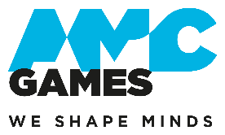 | AMC Games | http://www.amc.ro/
Just an experienced and awesome development team committed to create top notch video games.
Marcel Neamtu - marcel.neamtu@amc.ro

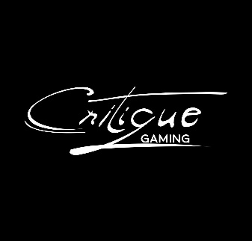 | Critique Gaming | http://critique-gaming.com  The Critique Gaming team is an eclectic squad of people with very different social educational backgrounds, from law and economy to art and programming, with very diverse skillsets. They have gathered with the mission of making pointful games that explore important contemporary questions.  Andrei Olaru – andrei@critique-gaming.com
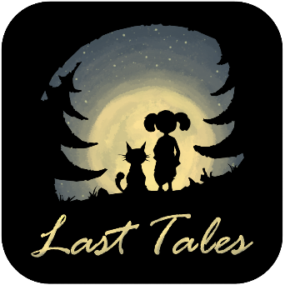 | Last Tales | https://www.raidersofthelostisland.com/  Last Tales is the studio behind the game Raiders Of The Lost Island, a local co-op party game where up to four players compete in looting treasures from a sinking island, while building together a raft to survive the final wave.  Alexandru Simion – contact@lasttales.com
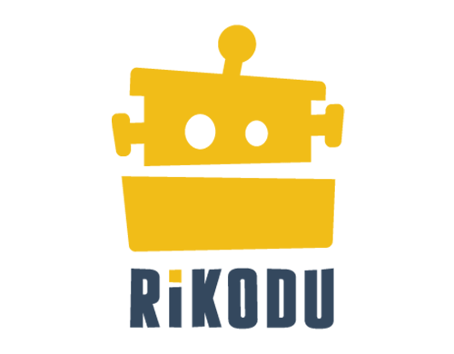 | Rikodu | https://rikodu.com/
Rikodu is a small team of veterans, with diverse backgrounds and a common mission: to make high quality games that are tuned for maximum fun. Their first game, Second Hand: Frankie's Revenge, a 1-4 player co-op game where players cobble robots together from junkyard parts, was just released in Early Access. Rikodu is looking to meet media interested in Frankie's Revenge as well as publishers and investors interested in future collaboration
Alexandru Palade - apalade@rikodu.com

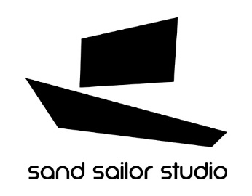 | Sand Sailor | http://www.blackthefall.com/sand-sailor-studio.html
Sand Sailor Studio is a Bucharest-based independent game development founded in 2014 in Bucharest, Romania. After releasing their first title, Black The Fall on PC, PS4, Xbox One and Nintendo Switch, Sand Sailor Studio is currently a fizzy team of eight working hard to deliver the latest mischief called Bossgard, a game about vikings fighting a Giant Loaf Of Bread. More on the team here: https://www.youtube.com/watch?v=kHjEzNAX93k

Cristian Diaconescu – Cristian.diaconescu@sandsailorstudio.com

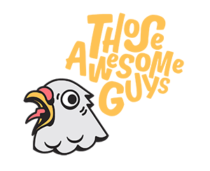 | Those Awesome Guys | https://thoseawesomeguys.com/
THOSE AWESOME GUYS is a small independent video game developing “studio” formed out of people from around the world with the purpose of being the developers and publishers we’d support as gamers. We made Move or Die and published Monster Prom.
Nick Berbece - nick@thoseawesomeguys.com

Tractor Set Go! | http://tractorsetgo.com/

Tractor Set Go! produces games and mobile apps for third party clients. They deeply enjoy these projects as a source of inspiration and as an opportunity to do greater things through collaboration. They’re also long time friends and our aspiration is to create beautiful and original gaming experiences. They learned a lot through their projects and challenges and now they are confident they can deliver a great game with creative and addictive mechanics. They are efficient in adding player oriented features and implementing solutions for revenue improvement.
Horea Trinca – contact@tractorsetgo.com

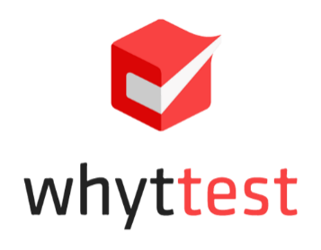 | Whyttest | https://whyttest.com/
Whyttest is a QA outsourcing studio, with a friendly culture and testing sites in Eastern Europe: Bucharest, Romania and Belgrade, Serbia. Since 2014, here you can find the perfect mix between “young bloods” and veterans of the industry. The teams consist of highly experienced QA professionals (10+ – 15+ years in different gaming companies) and young people, with great potential and fresh ideas. Forged in the fires of complex projects, their teams have deep expertise on all gaming platforms: PC, Xbox One, PlayStation 4 Nintendo Switch, Mobile Devices. They adapt to any partner framework or recommend their bulletproof standards, tools and pipelines, making them the perfect partner for any development team!
Cristina Bragarea – Cristina.bragarea@whyttest.com

MEET US
in Cologne!
Send us a meeting request on MeetToMatch.

ABOUT

The Romanian delegation at Gamescom is organized with by RGDA – the Romanian Game Developers Association, with the support of the Romanian Government. RGDA is a non-profit organization whose purpose is to support and promote the Romanian video game development industry, both at a national and international level. RGDA organizes Dev.Play, the conference for Eastern European game developers, every autumn. Meet us in Bucharest as well at Dev.Play this November! Learn more here: https://dev-play.ro/

CONTACT

Andreea Medvedovici-Per
Executive Director, RGDA
Email: andreea.per@rgda.ro
Phone: +40 734 802267

The Romanian Delegation at Gamescom 2019 is supported by the Department of Foreign Trade, Ministry of Business Environment, Commerce and Entrepreneurship, Government of Romania.

